

**МАНДАХ ИХ СУРГУУЛЬ**

МЭДЭЭЛЭЛ, ТЕХНОЛОГИЙН СУРГУУЛЬ

**INFORMATION SYSTEM**

**Хичээлийн нэр: Мэргэжлийн англи хэл 1**

**Хичээлийн код: ENG107**

**Оюутан: Жигмэд Болд-Эрдэнэ**

**Багш: ………………………..**

**УЛААНБААТАР ХОТ**

**2023 ОН ХАВАР**

**Information and Technology**

Information technology (IT) is the use of any computers, storage, networking and other physical devices, infrastructure and processes to create, process, store, secure and exchange all forms of electronic data. Typically, IT is used in the context of business operations, as opposed to technology used for personal or entertainment purposes. The commercial use of IT encompasses both computer technology and telecommunications.

The Harvard Business Review coined the term information technology to make a distinction between purpose-built machines designed to perform a limited scope of functions, and general-purpose computing machines that could be programmed for various tasks. As the IT industry evolved from the mid-20th century, computing capability increased, while device cost and energy consumption decreased, a cycle that continues today when new technologies emerge.

The basic concepts in information technology:

* Information security
* Software
* Hardware
* Database
* Network management

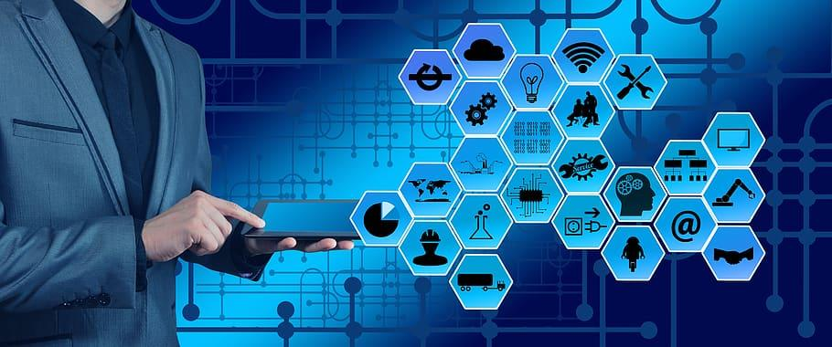

**Information security**

Information security (infosec) is a set of policies, procedures and principles for safeguarding digital data and other kinds of information. Infosec responsibilities include establishing a set of business processes that protect information assets, regardless of how that information is formatted or whether it is in transit, being processed or at rest in storage.

Generally, an organization applies information security to guard digital information as part of an overall cybersecurity program. Infosec ensures that the employees have access to the data they require, while preventing unauthorized access. It can also be associated with risk management and legal regulations.

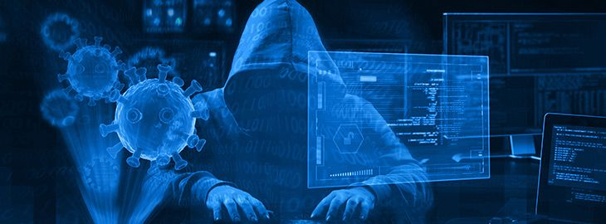

**Software**

Software is a set of instructions, data or programs used to operate computers and execute specific tasks. It is the opposite of hardware, which describes the physical aspects of a computer. Software is a generic term used to refer to applications, scripts and programs that run on a device. It can be thought of as the variable part of a computer, while hardware is the invariable part.

The two main categories of software are application software and system software. An application is software that fulfills a specific need or performs tasks. System software is designed to run a computer's hardware and provides a platform for applications to run on top of.

Other types of software include programming software, which provides the programming tools software developers need; middleware, which sits between system software and applications; and driver software, which operates computer devices and peripherals.

Early software was written for specific computers and sold with the hardware it ran on. In the 1980s, software began to be sold on floppy disks, and later on CDs and DVDs. Today, most software is purchased and directly downloaded over the internet. Software can be found on vendor websites or application service provider websites.

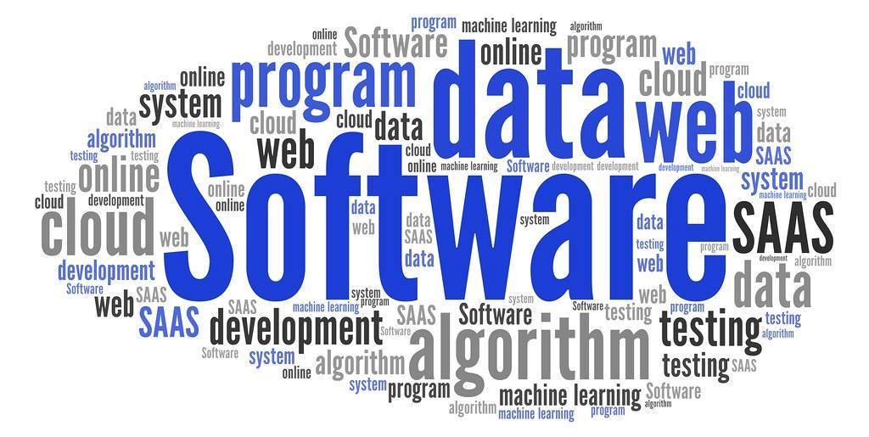

**Hardware**

Computer hardware is a collective term used to describe any of the physical components of an analog or digital computer. The term hardware distinguishes the tangible aspects of a computing device from software, which consists of written, machine-readable instructions or programs that tell physical components what to do and when to execute the instructions.

Hardware and software are complementary. A computing device can function efficiently and produce useful output only when both hardware and software work together appropriately.

Computer hardware can be categorized as being either internal or external components. Generally, internal hardware components are those necessary for the proper functioning of the computer, while external hardware components are attached to the computer to add or enhance functionality.

.

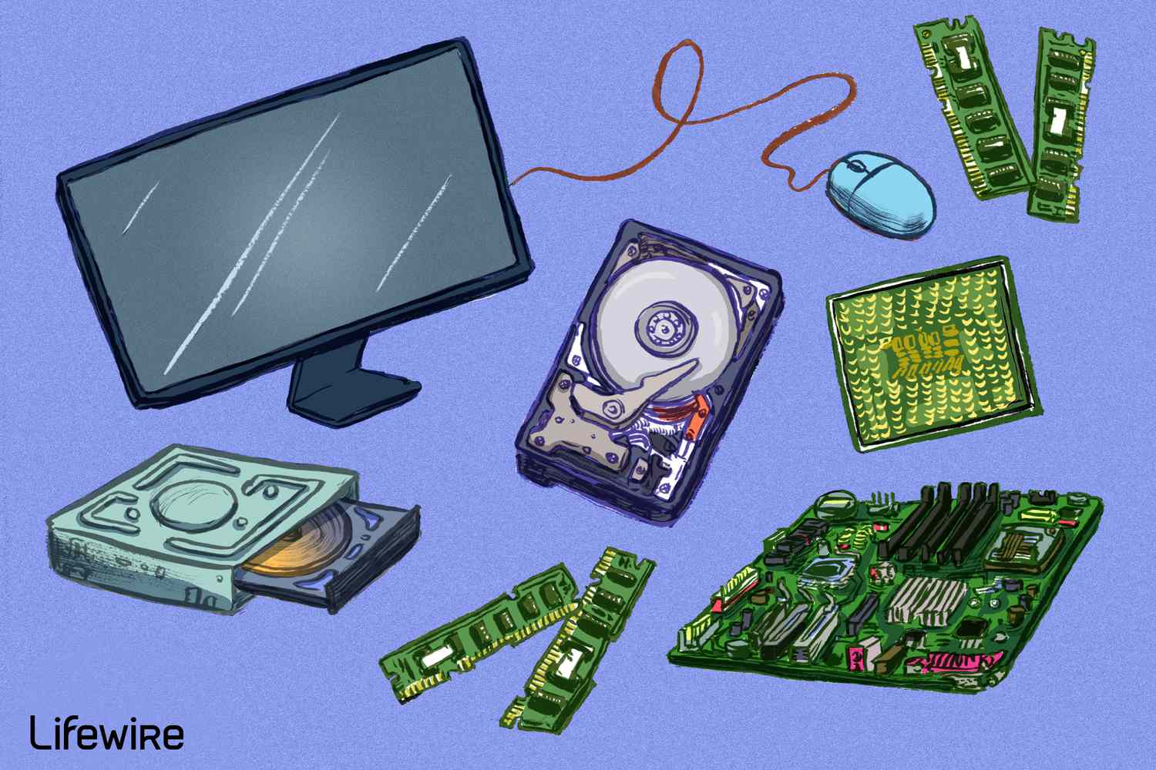

**Database**

A database is information that is set up for easy access, management and updating. Computer databases typically store aggregations of data records or files that contain information, such as sales transactions, customer data, financials and product information.

Databases are used for storing, maintaining and accessing any sort of data. They collect information on people, places or things. That information is gathered in one place so that it can be observed and analyzed. Databases can be thought of as an organized collection of information.

What are databases used for?

Businesses use data stored in databases to make informed business decisions. Some of the ways organizations use databases include the following:

Improve business processes. Companies collect data about business processes, such sales, order processing and customer service. They analyze that data to improve these processes, expand their business and grow revenue.

Keep track of customers. Databases often store information about people, such as customers or users. For example, social media platforms use databases to store user information, such as names, email addresses and user behavior. The data is used to recommend content to users and improve the user experience.

Secure personal health information. Healthcare providers use databases to securely store personal health data to inform and improve patient care.

Store personal data. Databases can also be used to store personal information. For example, personal cloud storage is available for individual users to store media, such as photos, in a managed cloud.

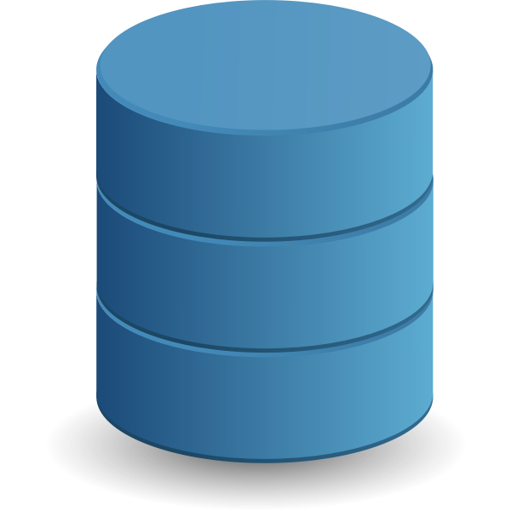

**Network management**

Network management is the sum total of applications, tools and processes used to provision, operate, maintain, administer and secure network infrastructure. The overarching role of network management is ensuring network resources are made available to users efficiently, effectively and quickly. It leverages fault analysis and performance management to optimize network health.

Why do we need network management? A network brings together dozens, hundreds or thousands of interacting components. These components will sometimes malfunction, be misconfigured, get over utilized or just fail. Enterprise network management software must respond to these challenges by employing the best suited tools required to manage, monitor and control the network.

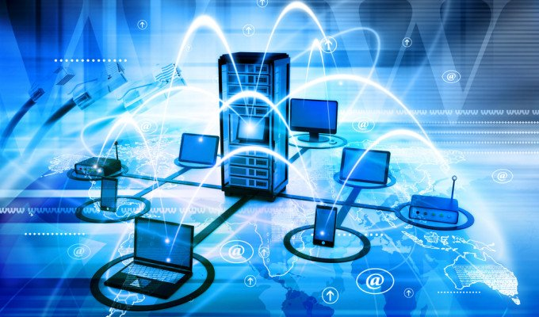

**Internet by the numbers**

In less than two decades, the number of people with access to the internet has skyrocketed. As of April 2022, more than 5 billion people used it worldwide, which is 63.5 percent of the world’s population—up from just 15 percent in 2005. Much of that increase is concentrated in the developing world.

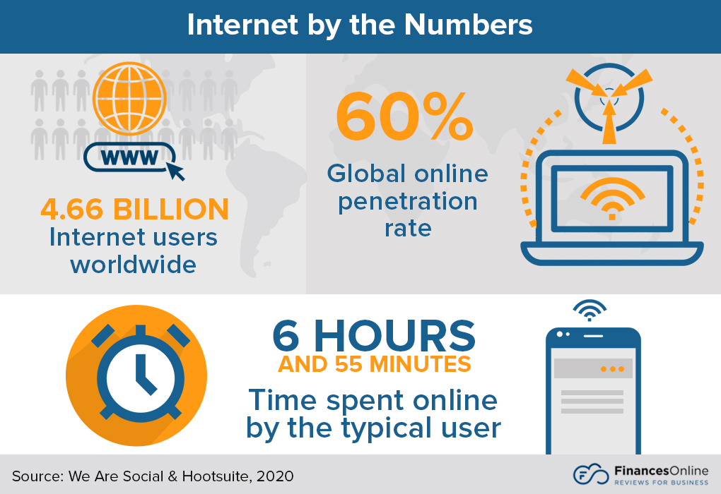

**Future of Information technology**

In the future, IT security will call for better training of individuals, but it will also call for more efficient methods. Artificial Intelligence will be able to easily solve these problems, though it will still be necessary to train individuals who are managing the machines .

.



**Sources**

* [https://www.google.com](https://www.google.com/)
* <https://en.wikipedia.org/wiki/Information_technology>
* Information technology book by Virginia Evans, Jenny Dooley, Stanley Wright.
* https://www.microfocus.com/en-us/what-is/network-management
* https://www.techtarget.com/searchdatamanagement/definition/database
* https://www.techtarget.com/searchapparchitecture/definition/software
* https://www.techtarget.com/searchsecurity/definition/information-security-infosec
* https://www.techtarget.com/searchnetworking/definition/hardware